**PC Retailer Order System – Design Overview**

This report is a summary of the PC retailer ordering system, its key packages, interfaces, and classes.

# Overall Structure

* Domain model package: This package defines preset and custom computer models are the immutable value objects.
* Customer and payment packages offer verified documents of buyers and their credit cards.
* Place order packages, cancel, fulfil and analytics using a service facade.

# Key Interfaces

* **ComputerModel:** Base contract exposing model identity and the set of parts.
* **PresetComputerModel:** Extends ComputerModel to include the originating manufacturer.
* **CustomComputerModel:** Adds immutable part addition and removal operations that return new instances.
* **CustomerOrder:** Read-only view on orders so clients cannot bypass lifecycle checks.

# Principal Classes

* **PresetModel:** Immutable preset machine; validates manufacturer, name, and parts.
* **CustomModel:** Immutable custom machine supporting copy-on-write part changes.
* **CustomModelFactory:** Tracks allocated custom names to enforce uniqueness.
* **Customer:** Immutable identifier/display-name pair with non-blank validation.
* **CreditCard:** Immutable credit card record providing defensive copies and expiry checks.
* **CreditCardFactory:** Allocates unique card numbers and constructs CreditCard objects.
* **OrderLine:** Pairs a ComputerModel with a positive quantity for basket lines.
* **StandardOrder:** Concrete CustomerOrder controlling status transitions internally.
* **FulfillmentPlan:** Collates manufacturer model totals and part counts for fulfilment.
* **OrderAnalytics:** Stores cumulative statistics such as top customers and parts.
* **OrderService:** Central façade coordinating placement, cancellation, fulfilment, and analytics updates.

# Order Lifecycle and Analytics

OrderService cheques card currency and order lines prior to order placement. The cancellation may be done up to the fulfilment. Fulfilment creates a FulfillmentPlan that condenses pre-established requirements by the manufacturer and parts to be used in custom builds. The same operation synchronises cumulative analytics therefore without having to replay history to query top customers, preset models, and custom parts.

# UML Class Diagram

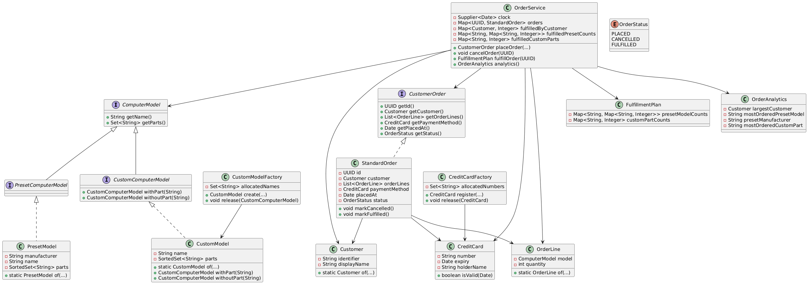

Figure: Core interfaces and classes with their key relationships.